**Elastic Search**

Elastic search is document (JSON) oriented, mainly used to search documents. Also, can insert documents, delete documents, retrieve documents, Analyze and search documents.

Elasticsearch is built on a search software **Lucine** which was released in 1998 as a part of an Apache project. The underlying software used in this software is **Inverted Index.**

**Inverted Index**: Maps words or numbers to the actual document locations of where they occur.

Inverted index allows fast full-text searches. It consists of unique words that appear in any document, and for each word lists all documents in which it appears.

Look below link to details.

<https://www.elastic.co/guide/en/elasticsearch/guide/2.x/inverted-index.html>

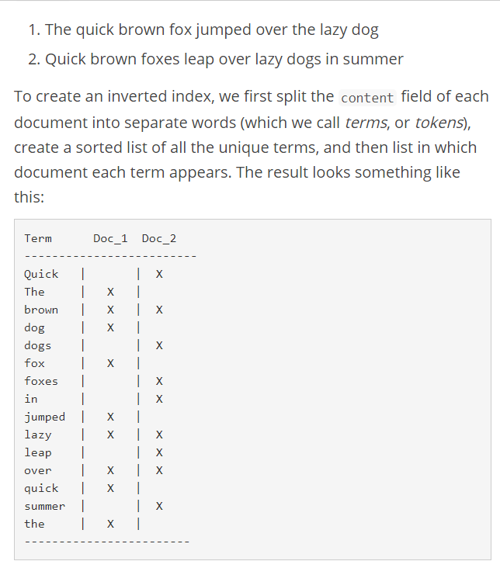

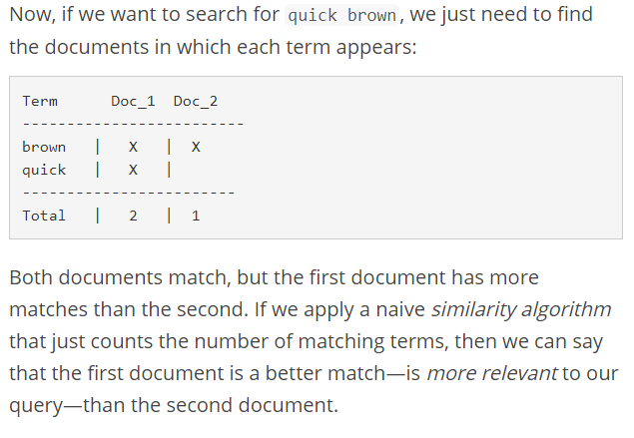

**Indexing, Retrieving and Deleting Data:**

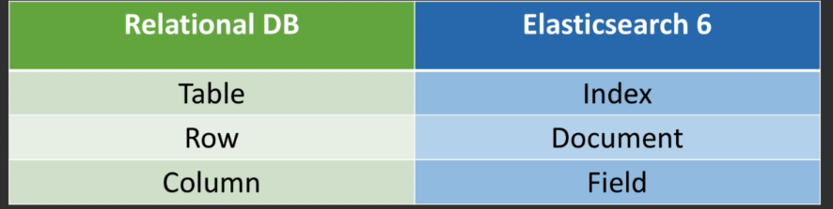

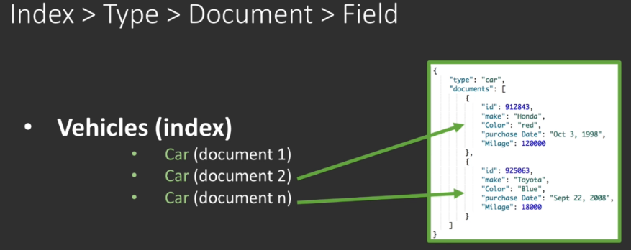

Indexing a document means to insert the document in to elastic search.

Command to index:

Type is deprecated in latest versions of elastic search.

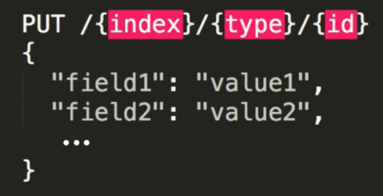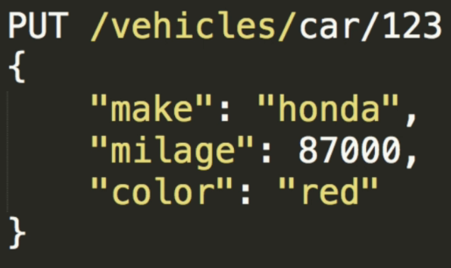

In latest versions of elastic search “type” is eliminated. There should be only one type of vehicle.

Index from Kibana:

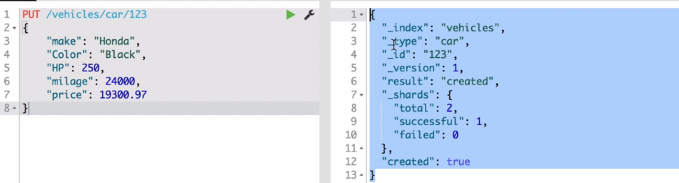

**Fields with “_” means meta fields managed by elastic search.**

If you run same document again version and result will be changed.

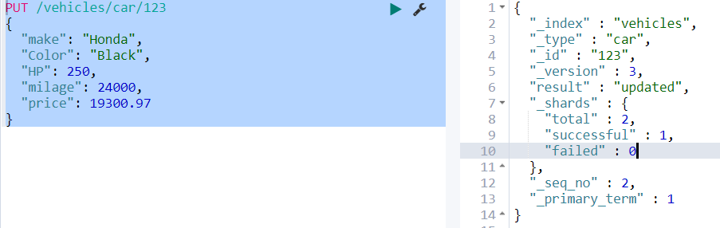

PUT /vehicles/car/123

{

"make": "Honda",

"Color": "Black",

"HP": 250,

"milage": 24000,

"price": 19300.97

}

**Retrieving:**

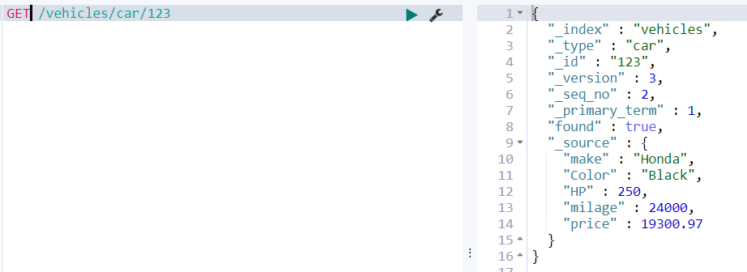

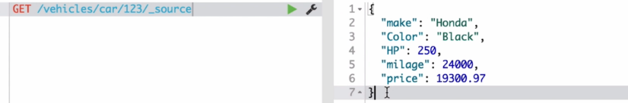

In order to check if the document exist:





If we change any field and PUT then it will update entire document, because documents are immutable. Cannot change specific fields, entire document will be changed. It is unlike from relational databases.

Even when use “_update” end point along with the URL. It still going to read the document and merge with new field and re-indexes it back. **Still the granular level of operation is being done at document level not field level.**

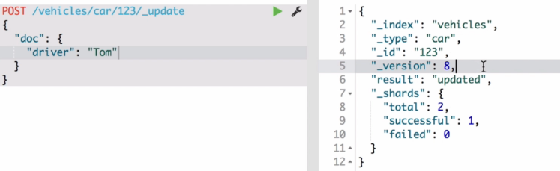

**Delete:**

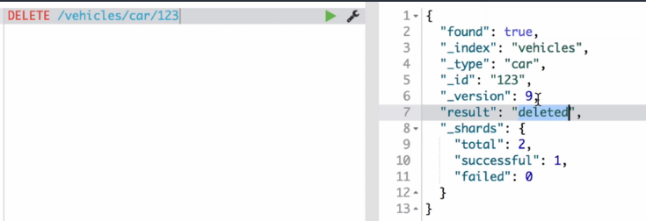

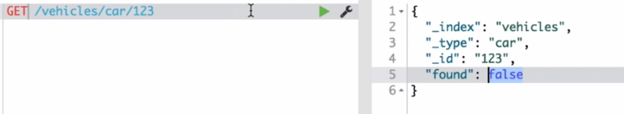

Behinds the scenes elastic search collects those documents and marks them as deleted but disk space will not free up immediately.

We can also delete “Type” or “Index” as well.



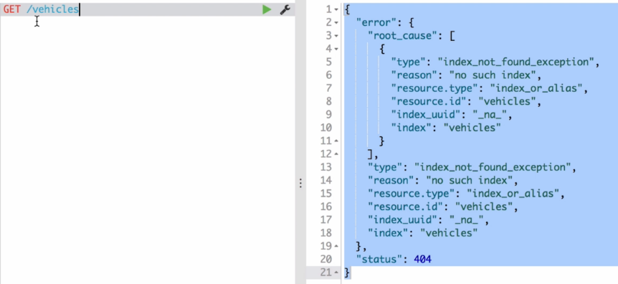

**Structure of Index created by Elastic Search:**

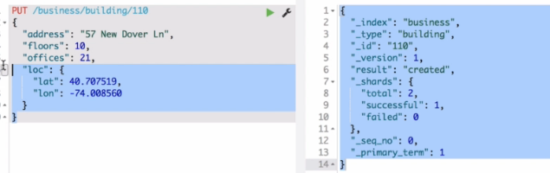

**Structure:**

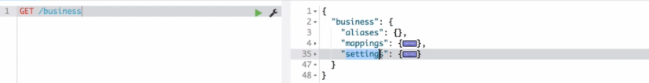

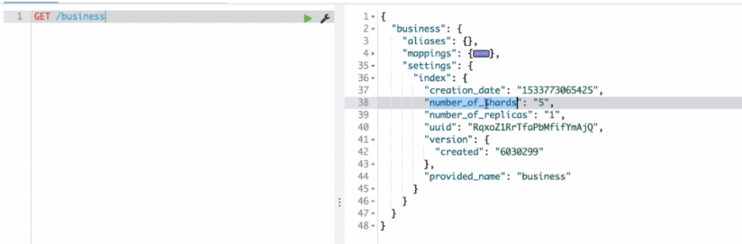

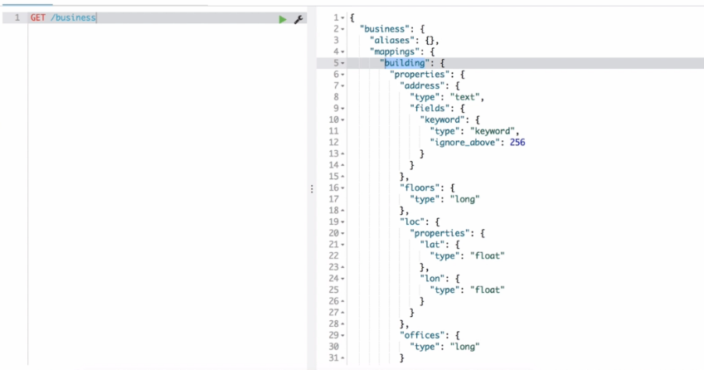

When you add the new fields, elastic search is able to manage the structure by adding the fields dynamically.

There can be only one mapping to an index. Cannot index multiple types.

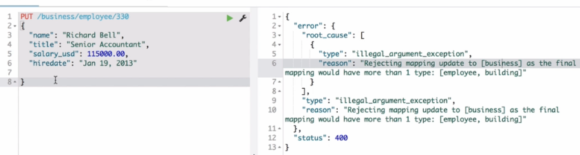

Creating Employees:

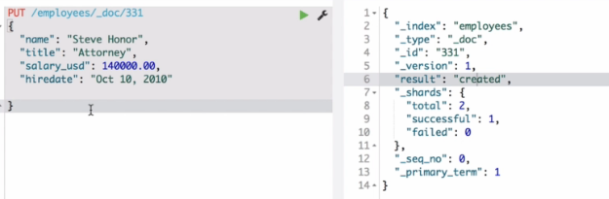

Indexing:

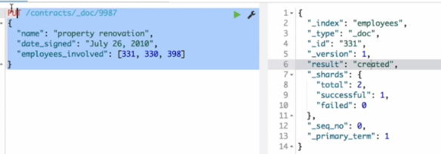

**Query the documents:**

Can query using GET method and “_search” end point. This will respond with the information like below. The main documents are under array of Hits.

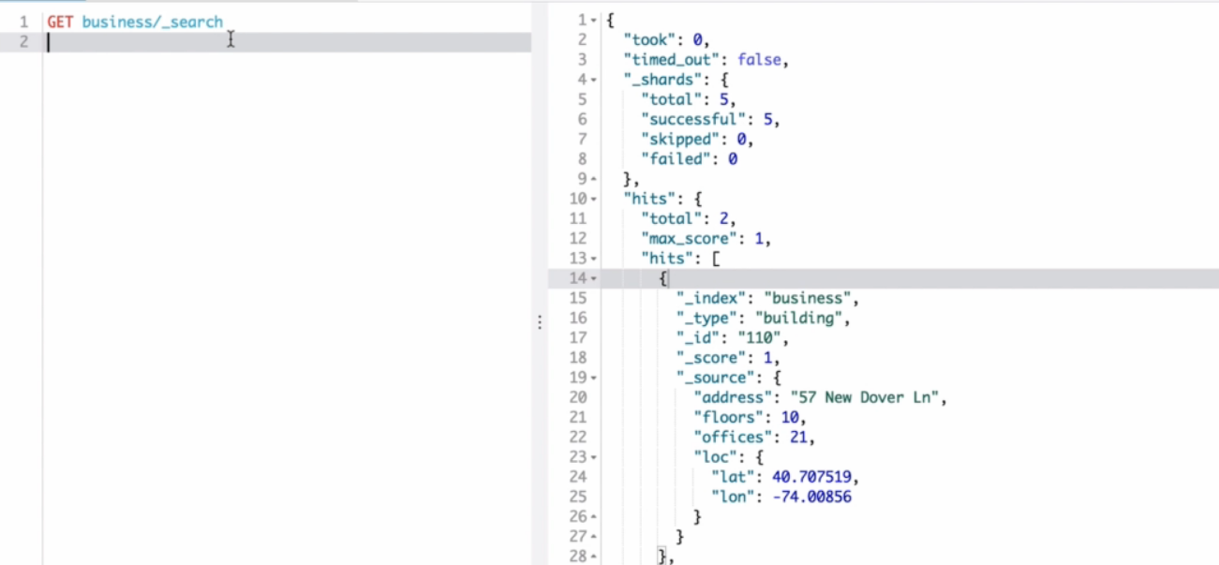

If we want to get the address that has “pen” we can use below “term” query.

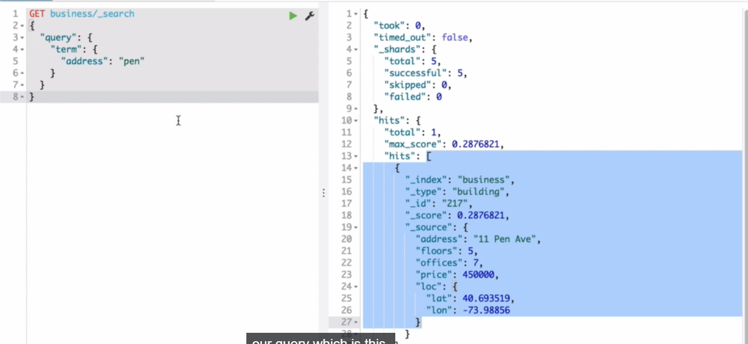

Internally it is converted like this

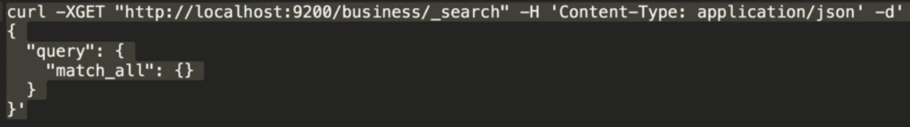

Also, can be invoked from terminal.

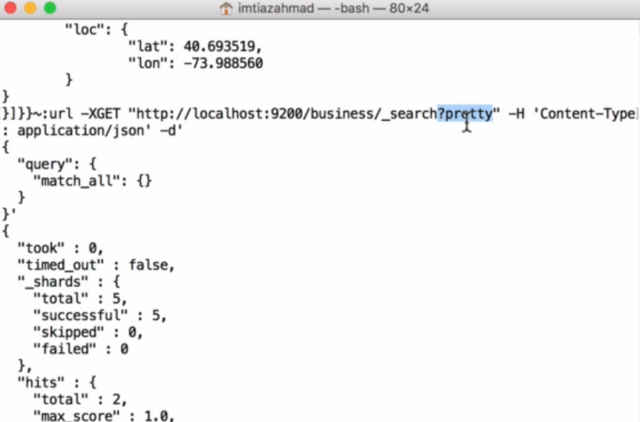

**Distributed Execution of Requests:**

* Elasticsearch is a distributed technology. Distribute the problem among many nodes, so that all work in parallel and respond faster.
* In settings schema of an Index, there are fields like shards and replicas.

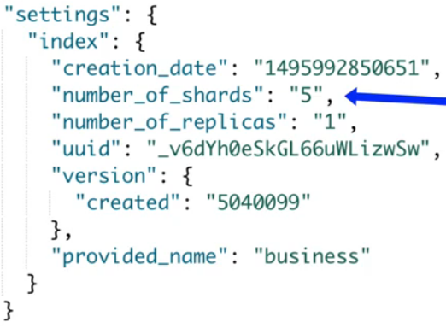

* The logical representation what we assume is different from the physical representation of an Index.
* Index internally Splits up into multiple **shards** and storage is distributed between them. Shards are the actual containers of data.
* Shards come in to picture in order to divide the data between multiple nodes.
* **Replica** is the exact copy of the shards.
* Shard and its replica will not be on the same node, because if node goes down, we need to recover from replica.
* **All these cluster of nodes makes up elastic search**.
* Any node can handle any kind of request, internally it forwards the request to respective node as per requirement.

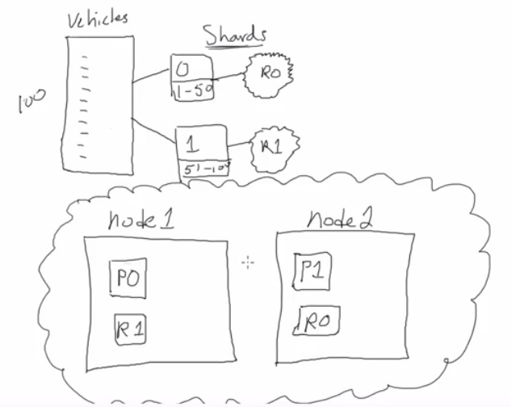

**Index request:**

If we do an indexing to a particular node, internally node performs hashing algorithm and forwards the request to respective node. After successfully indexing it will send a signal to update all the replicas in different nodes.

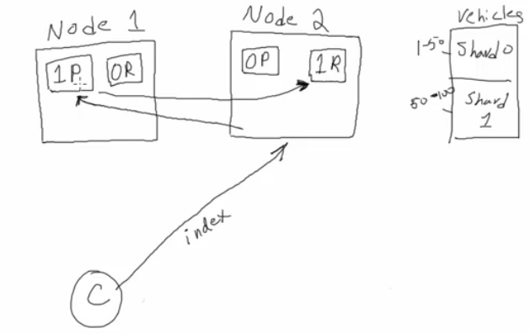

**Delete request:**

It also works similar to Index request. As all nodes know where the all documents are, the delete request is forwarded to respective shard in different node based on hashing function. Once the document is deleted it send the signal to all replicas in different nodes and performs delete.

**Get request:**

Elasticsearch uses load balancers to reading data faster. So, if you GET a request it distributes the load between the nodes that are having shards and nodes that having its replicas. Internally uses **Round-robin algorithm**, which says to go in particular order over a certain set of nodes rather than hammering one.

Elastic search index is the logical representation of the index. Physical containers of data is actually shards and that is how an index could be split amongst cluster of nodes. Means each node contains a part of data that is shard.

**Shard**: It is a Lucine index. (searching power comes from Lucine).

* Shard internally consists of segments (Inverted Index).

Let’s take a document of play, we need to split that long list of words (tokens) in alphabetical order and next to each word we put the document and its location.

Index 🡺 multiple shards 🡺 each shard to many segments (IDx).

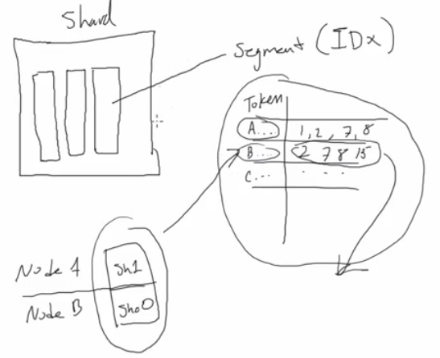

**How Indexing works:**

* It is slowest process.
* Elastic search needs to prepare the data and run it through the process of analysis.
* Analysis is the process of taking Raw text and converting in to inverted index. So that data is searchable.
* If you send a JSON document, it process through the Elasticsearch analysis and broken down in to terms or tokens and indexes are created and stored in a memory buffer. When this buffer got filled up all these Inverted indexes are transferred to segment, and it continues till the segment got filled up.
* These segments once filled becomes Immutable IDx and shard will become searchable.

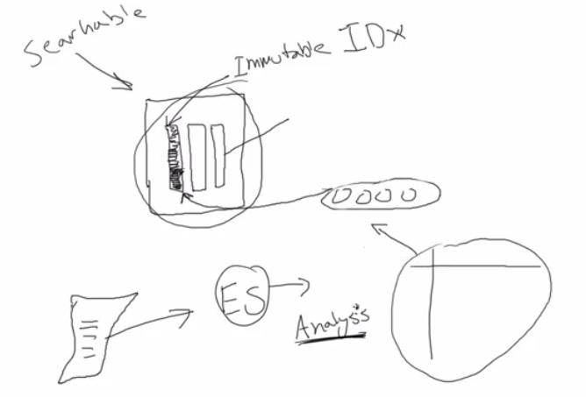

**Text Analysis for Indexing and Searching:**

* Split the text in to terms or tokens and sort them in alphabetical order.

Remove Stop words: specify to remove unnecessary terms.

Lowercasing: To get data case insensitively.

Stemming: To hold up to the root of the word. Let’s suppose Swimming and Swimmer, here the root is swim.

Synonyms: like the words skinny and thin.

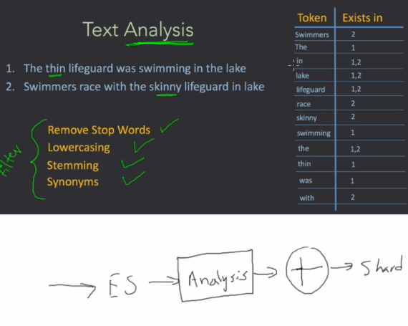

In Analysis step text processed through analyzer which internally has two steps.

1. **Tokenization**
2. **Filters**

Document first goes through the Tokenizer step and all the tokens then process through filters. The remaining tokens thus form an Inverted index.

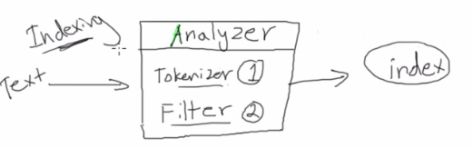

Analyzer comes in to picture even for Querying. If we give any match for searching it goes through tokenization and filtering and removes the stop words and results the main word.

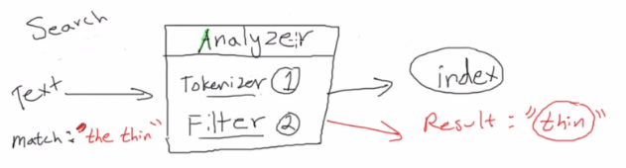

Below is the inverted index after filtering.

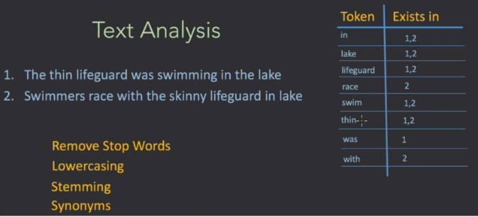

Elastic search has prebuilt analyzers and also can create custom analyzers using prebuilt filters.

We need to enable the analyzer on the specific field of a document. So that particular field goes through analysis.

**Same analyzer should be applied during the index time and query time.**

We can configure the index structure manually.

Those configuration settings need to be configured first before throwing any data in to it**.**

**Defining the Index Structure:**

Till now we directly defining documents and Elasticsearch can be able to figure out index structure on the fly. Now we will define the structure of Index.

Index structure for Customer:

Defining settings:

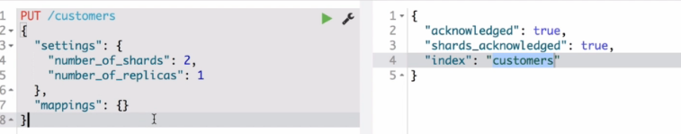

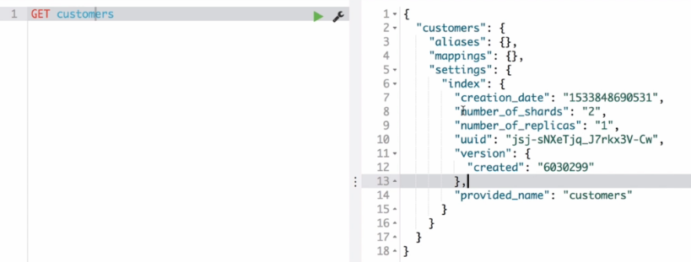

Mapping section will have meta data about fields. ES 6 or greater can have only one mapping. In future it will be completely removed.

Here we need to define properties and for each property it should have type and analyzer.

Standard analyzer tokenizes and converts in to lower case.

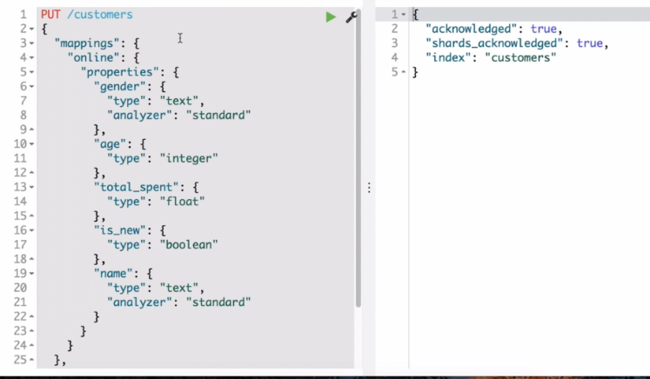

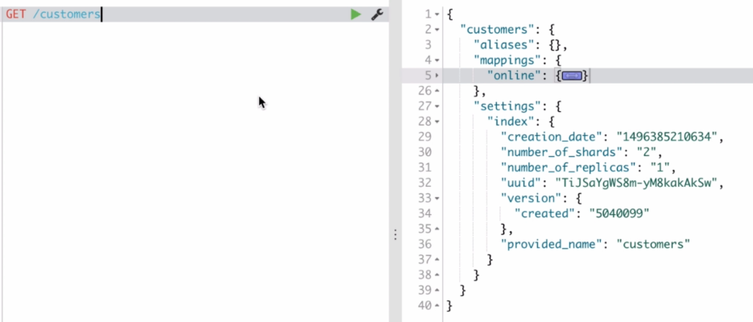

When we put additional fields that are not in defined structure, Elasticsearch will figure out the data type and field will be indexed. It updates the mapping.

Elastic search by default performs dynamic mapping. We can restrict this to happen at the time of defining structure or after the creation.

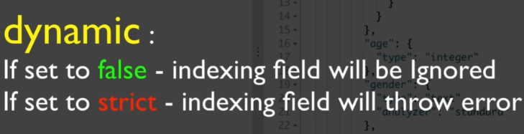

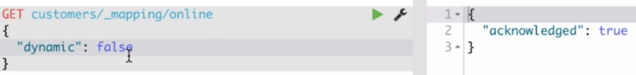

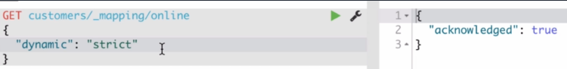

Strict also throws error.

Now if we try to add another field in document it will raise an error.

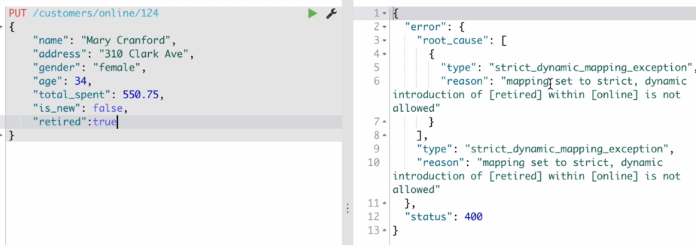

We can test the analyzers like below:

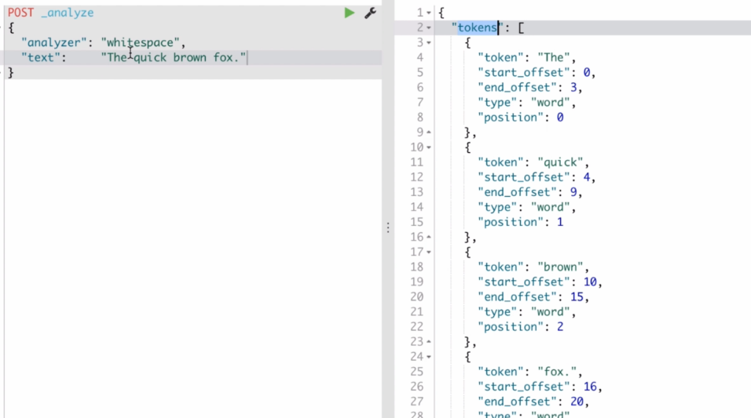

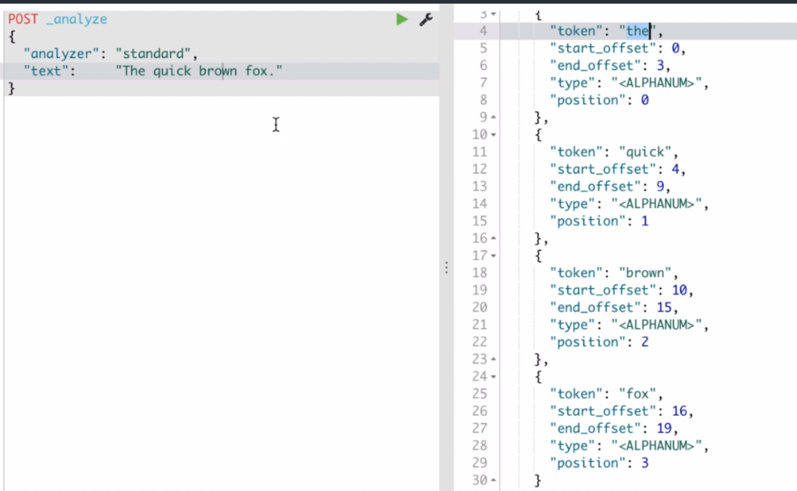

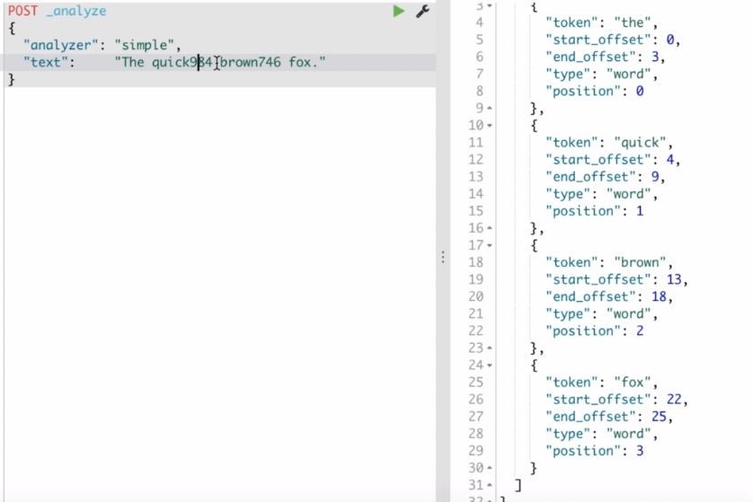

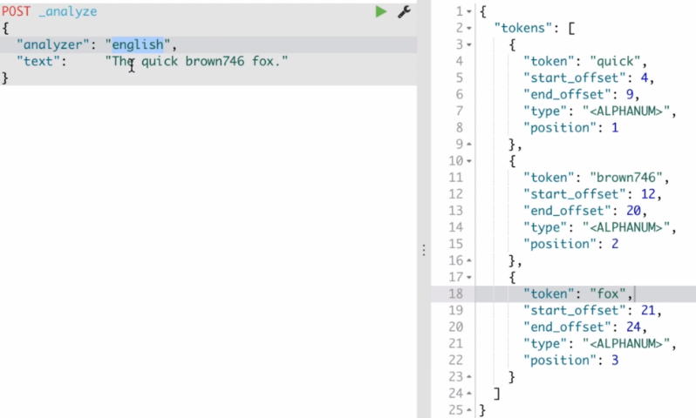

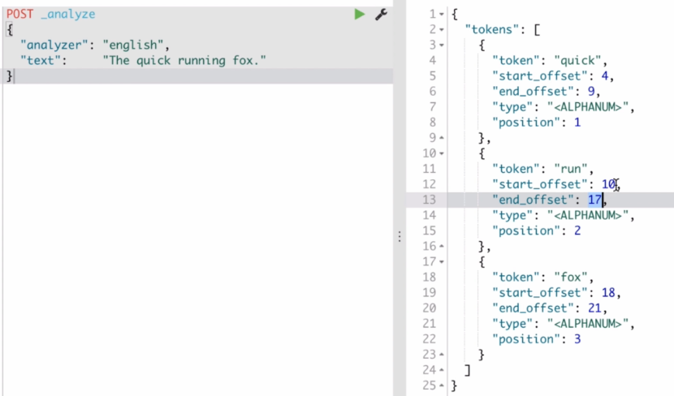

Custom Analyzer:

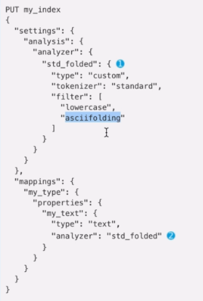 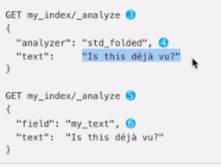

**Search:**

Elasticsearch is JSON over HTTP. We provide HTTP URL and endpoints (Indexing or Querying) and Body of request contains JSON.

**Domain Specific Language (DSL):** Specific structure of language that ES can understand. If you change the structure ES will give you error.

* ES provides a **relevancy score** so that more relevant documents appear towards the top of the search results.
* Syntax for Search DSL: two major search syntax components
  + **Query Context:** for **full text searches**. It matches documents that contain the search criteria as well as specify how well the document matched by giving relevancy score.
  + **Filter Context**:
* Generally, both query context and filter context are combined to form one large query.

Query Context:

1. MatchAll Query:

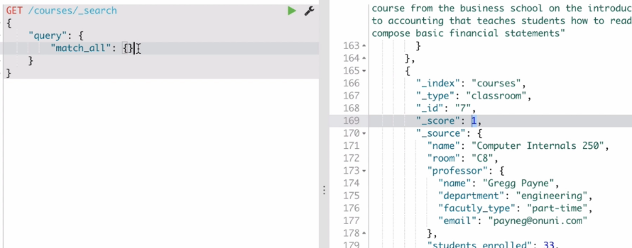

Here, Relevancy score is 1

1. To match a value:

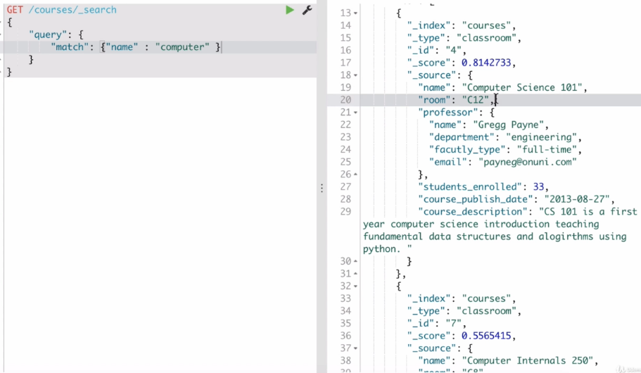

The 2 hits have the different scores 0.81and 0.55. The one with 0.81 has more relevancy. ES internally performs many aspects and gives the score.

Suppose if you change the course 7 with different name has 2 computer words then

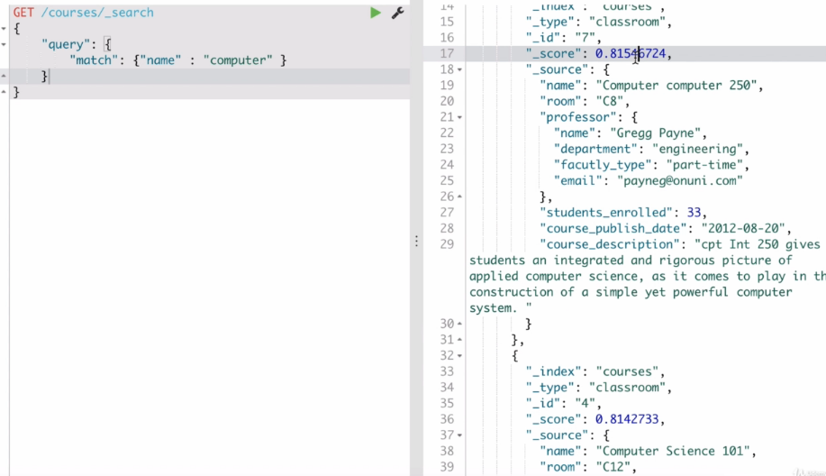

To check if field exists:

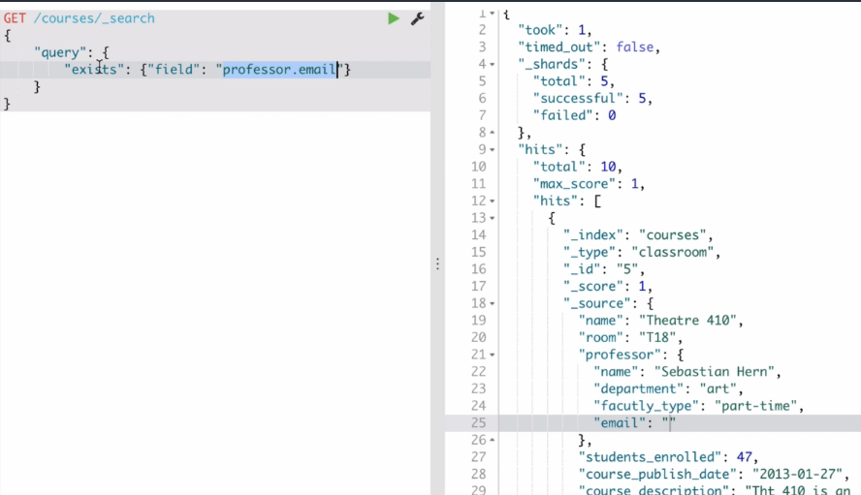

To query with two search criteria:

We should use “**must**” array with match JSONs and it should be wrapped inside “bool”.

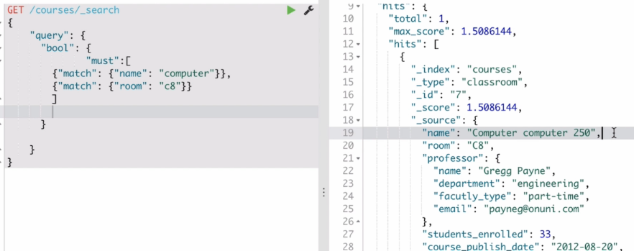

Must_not:

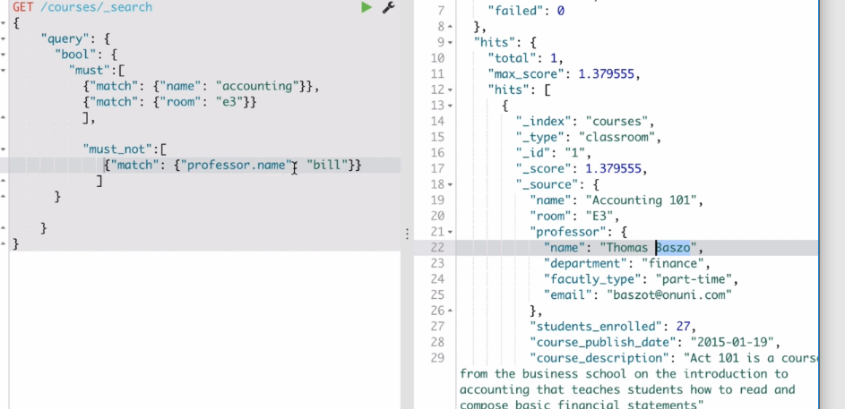

Should:

Usually “must” will have more precedence than “should”. It will be ignored every time. We can specify “minimum_should_match” says ES minimum one of matches in should need to match.

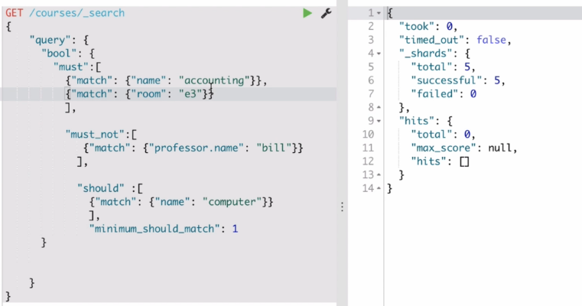

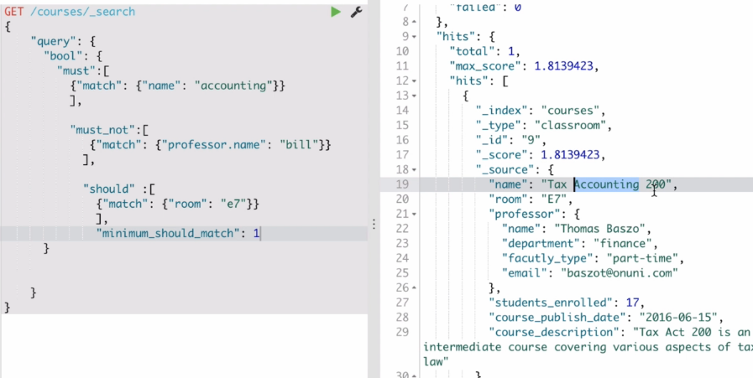

Multi_match queries:

Need to specify the all fields that needs to search and query to search. There is no must to have the query in both the fields. It will respond with appropriate relevancy scores.

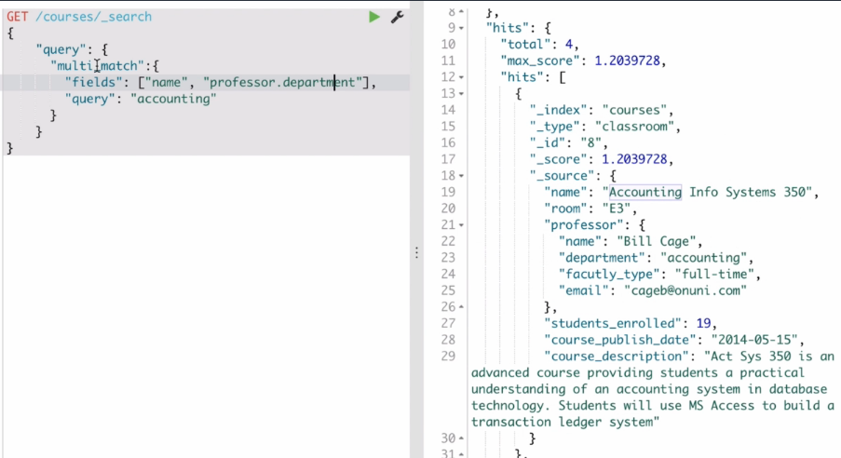

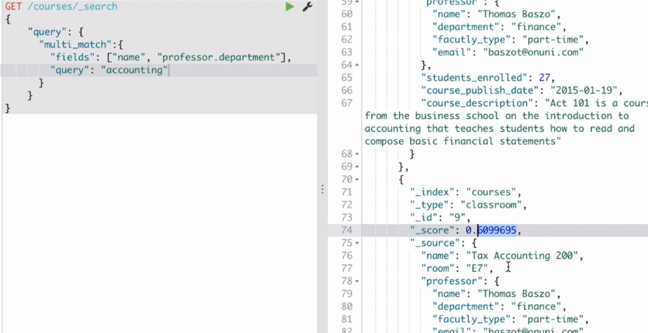

Match_phrase: to match a sentence or part of sentence.

It will break the phrase in to tokens and find the document. If you not give the correct phrase it will not give you the result.

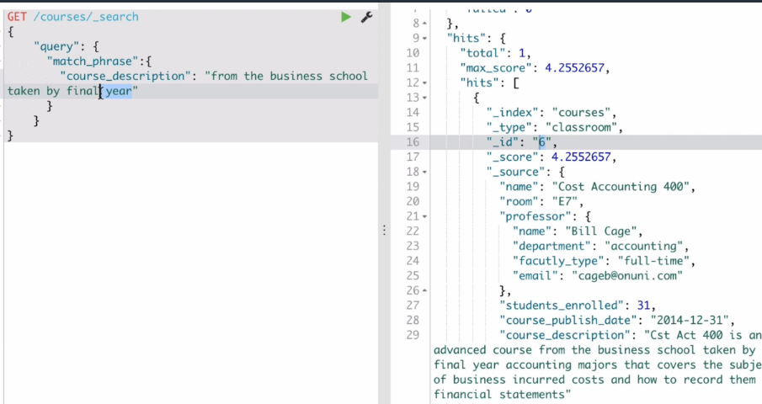

If you break the token it will not work

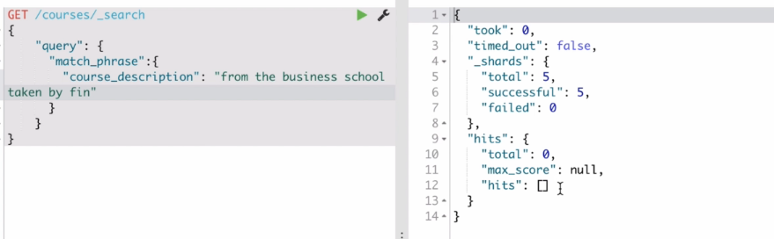

So, by using the “match_phrase_prefix” partial tokens can be figured.

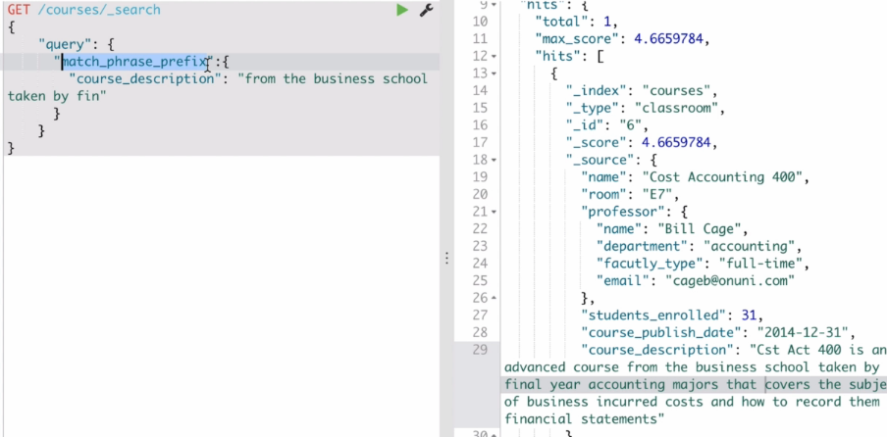

Range: Can be used on numeric fields.

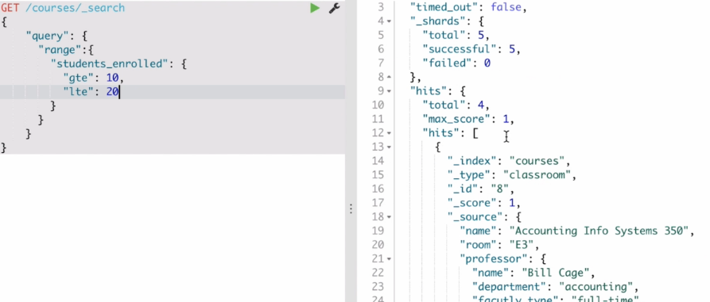

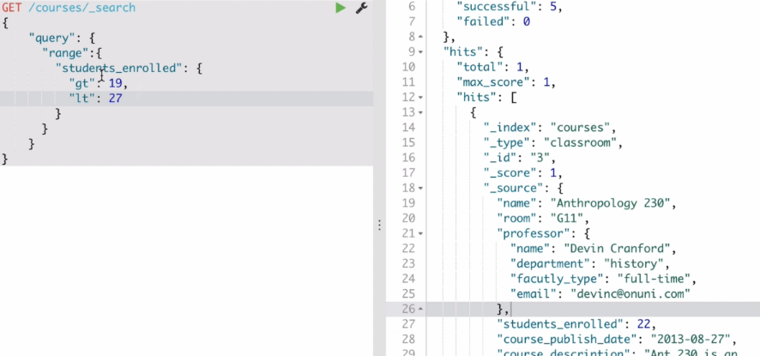

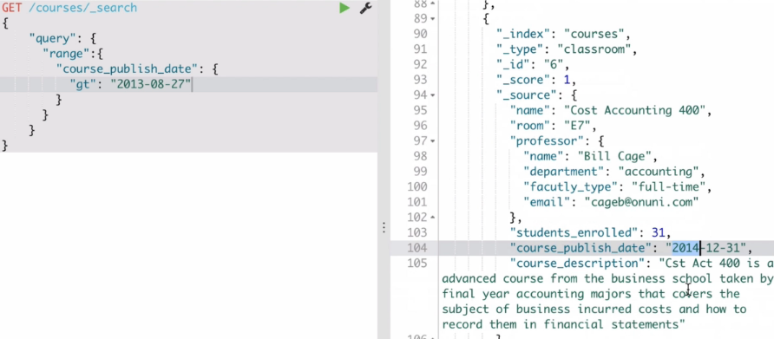

In the below query we used should, but we also got the results with range greater than 20 because it is in should. The one which is range has more relevance than the other. Should is just just an ideal situation not enforcement.

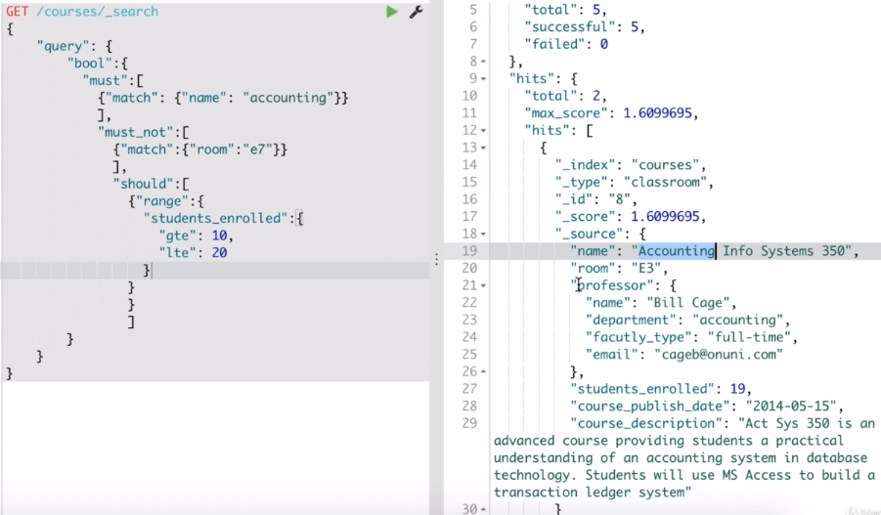

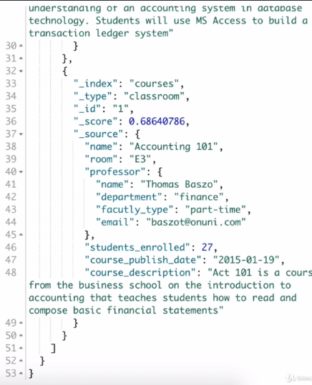

To make should to must we use “minimum_should_match” to 1

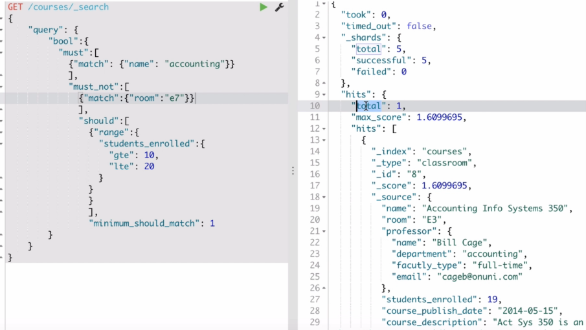

Filter Context:

Also comes inside Query Context.

The major difference between filter and query is filter does not do relevancy scoring.

* The filter is just filtering the documents that we need, just like database queries without any relevancy or importance to the documents.
* Filter caches the query and things work faster using it.
* If you don’t care about the relevancy score then better go for filter

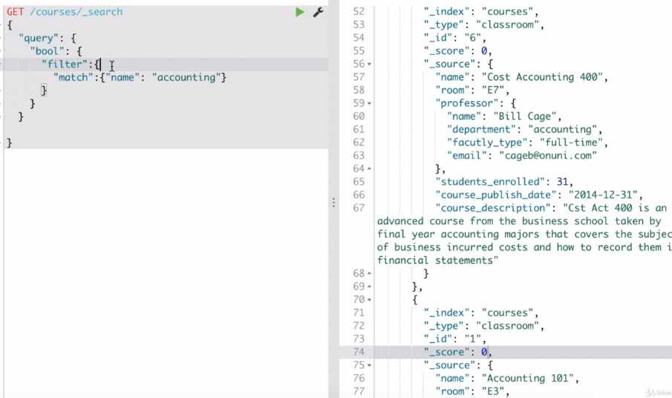

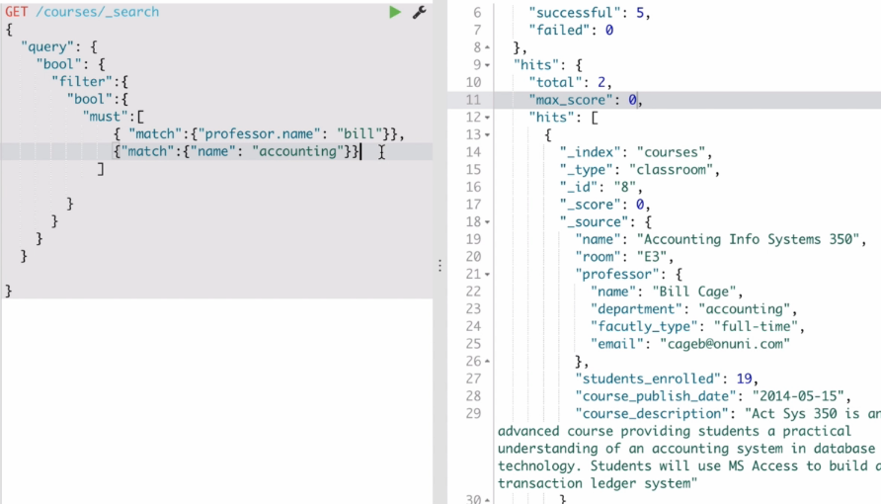

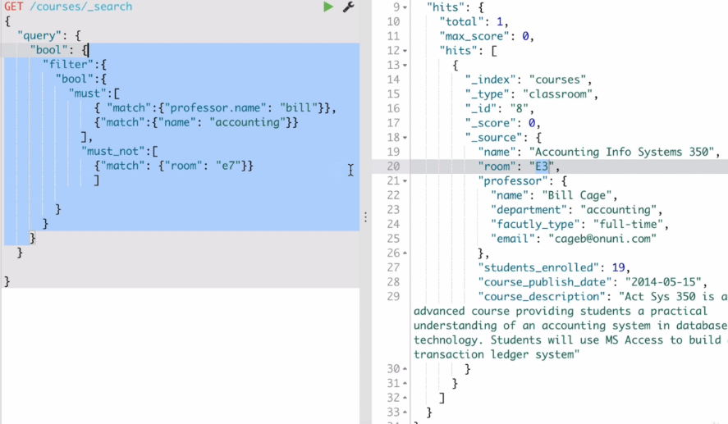

Below must is not in filter context it is in query context. So we get the relevancy score for that query context match.

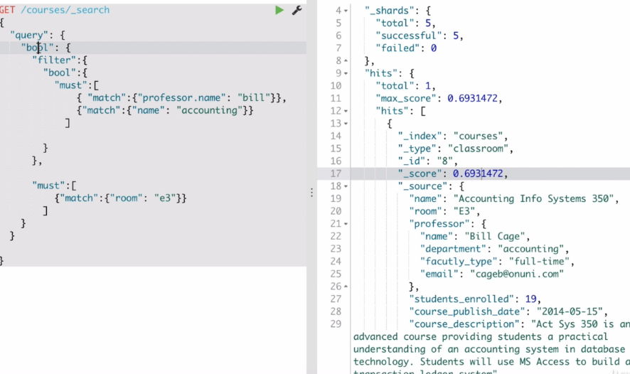

The only courses with E3 has the scores other have Zero.

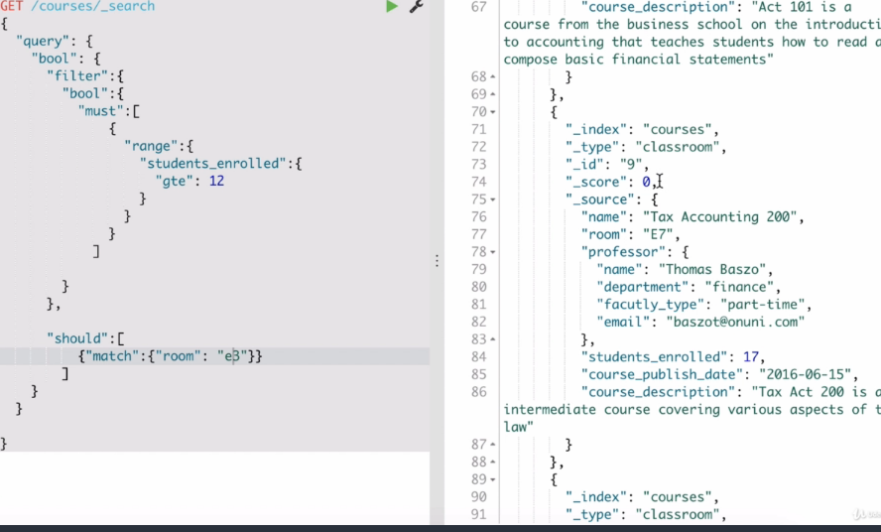

The score is highest because both should clauses matches.

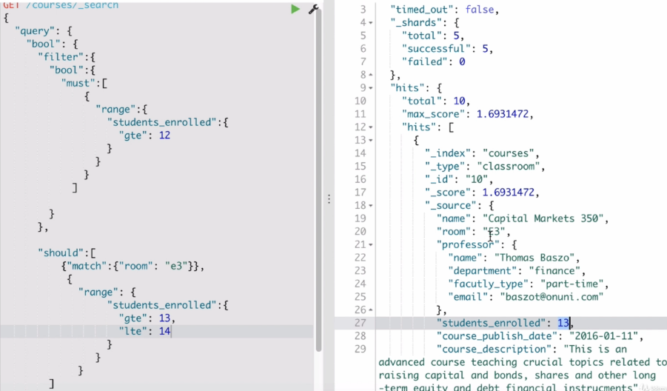

Altering the relevancy score that assigned to a document on which field is important is known as **field boosting. (^)**

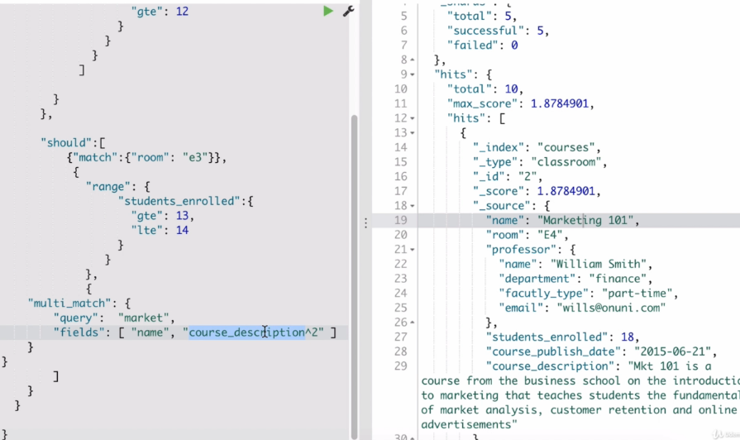

**Aggregations**:

BULK INDEXING: we can do it by using the bulk endpoint.

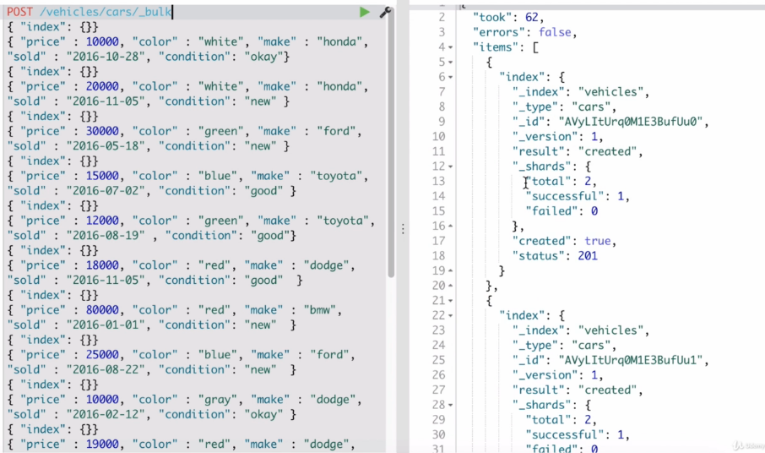

By default, only 10 will be shown on the kibana console. We can specify the size manually to display more documents.

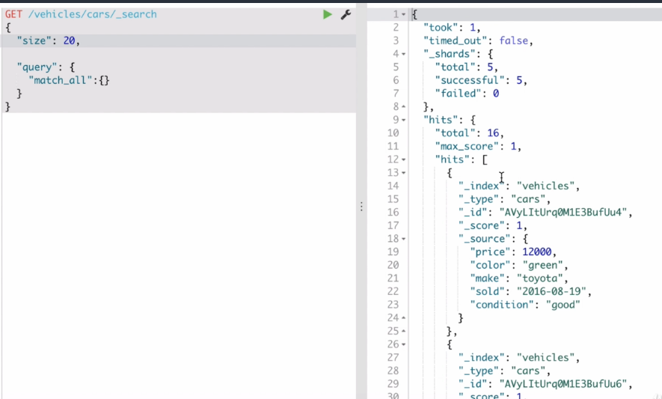

We can also define pagination using “from”

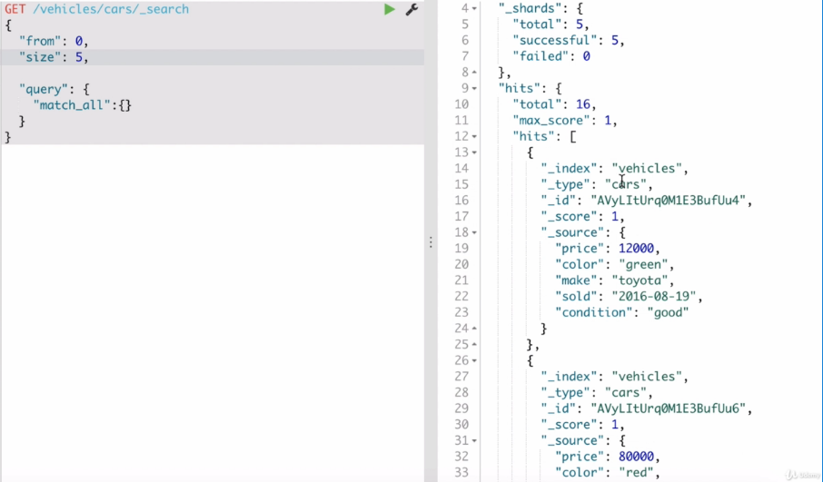

Sort:

Mechanism here is query and fetch, first it will do the query work and then it fetches.

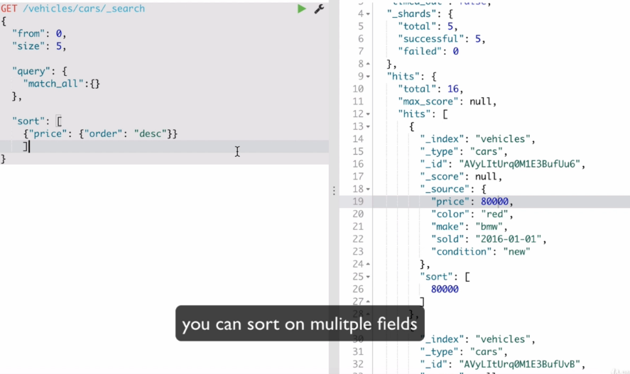

* Aggregations allow for powerful data analytics.
* Search is just running a query and find the documents that matches our search criteria, whereas aggregations are to gaining insight in to your data from high level view. This aggregation is done through **summarization**.
* Aggregations allow grouping or bucketing data and it is faster than group by in relational databases.
* This makes ES technology not only a search engine but also a big data processor.

Basic way of aggregating:

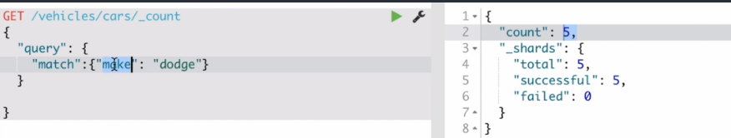

Example 1 aggregation: number of different cars.

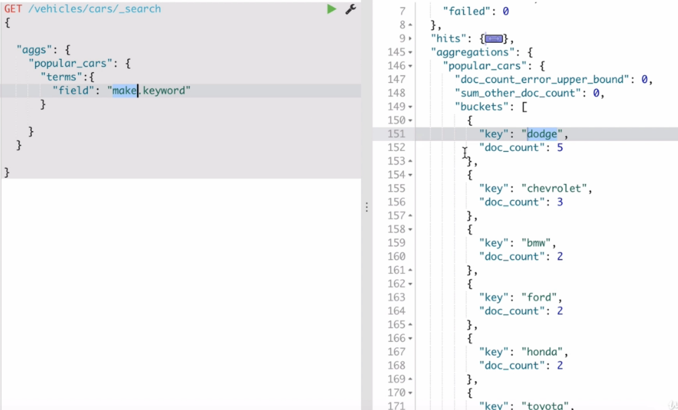

**Here based on field in the terms ES is giving the aggregations on that field.**

**doc_count gives how many documents that have key.**

**Make.keyword:** usually elastic search converts text in to inverted index. In case of aggregations we need to give the exact keyword so that it can run the aggregations. If it is text of sentence, then ES doesn’t know which word to consider. So, in order to specify ES it is only one complete thing we need to give “keyword”.

Example 2 : Average price for manufacturer.

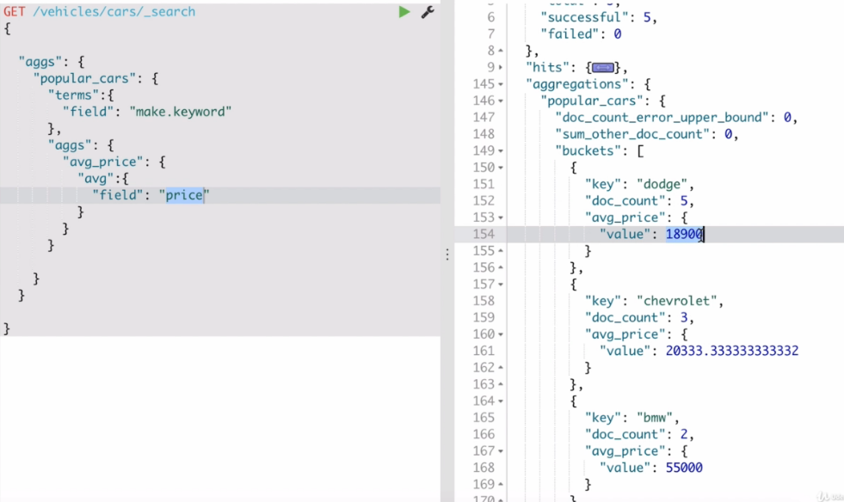

Here we got the average price for type of car.

Also, field “price” doesn’t need “keyword”, because it is not textual field.

Similarly, can find min and max price as well.

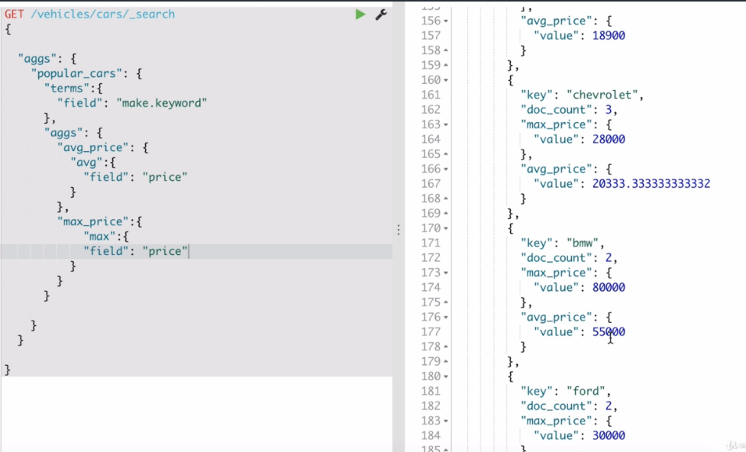

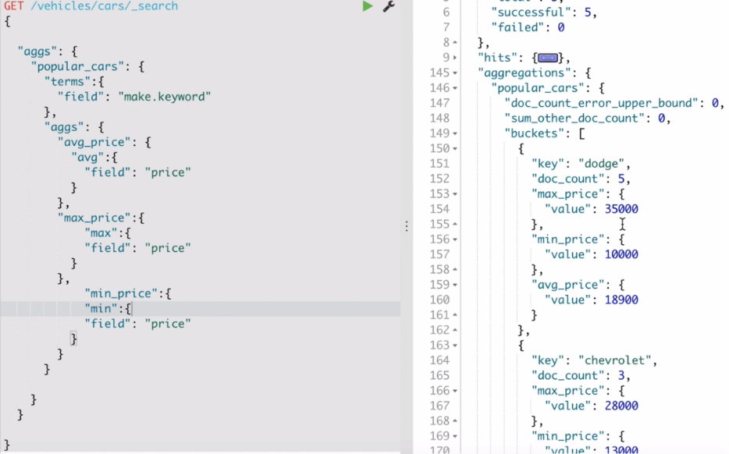

In the below search ES performs aggregations in the scope of query results.



If you keep size to zero, then documents will not be displayed.

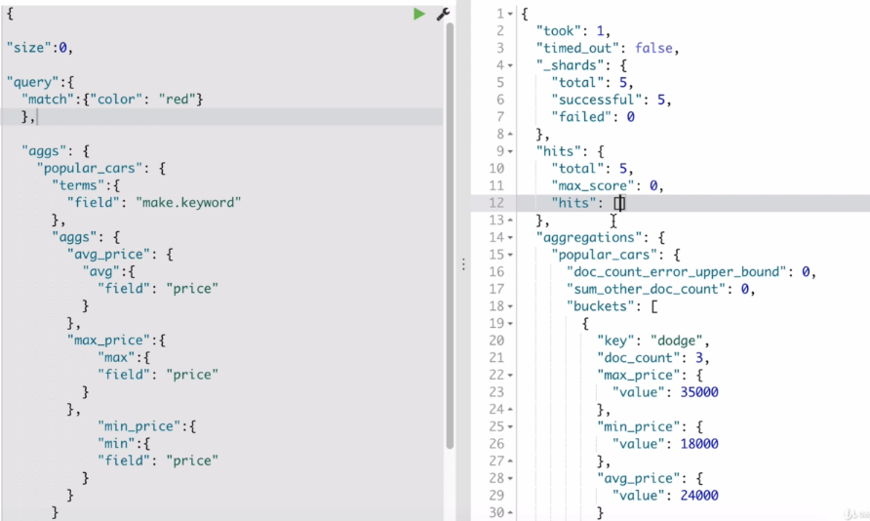

Instead of using min, max, avg we can just use stats.

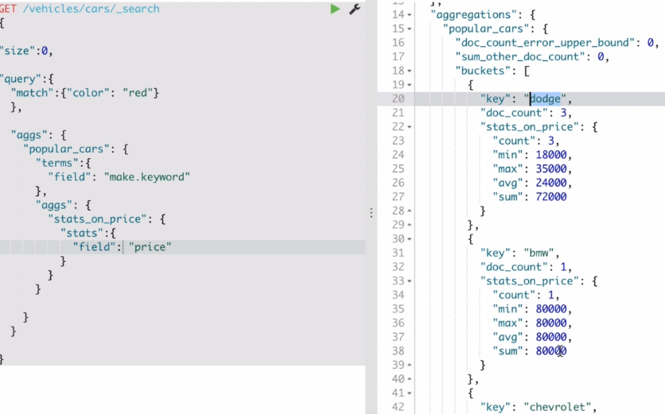

**Buckets and Metrics**:

In the above example “popular_cars” is the bucket on the field “make”.

There is a metrics “stats_on_price” where we also specify the field like “price”.

Here we can say there are buckets like dodge, bmw, Chevrolet.

**To get the cars sold in date range:**

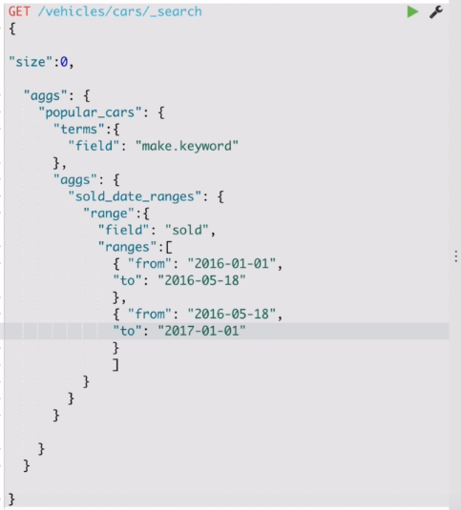

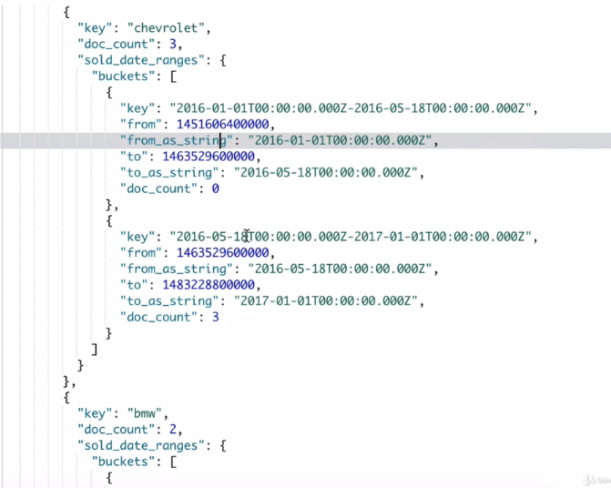

If you want to find the average price of the cars in that particular ranges.

Here we use the aggs inside the inner bucket.

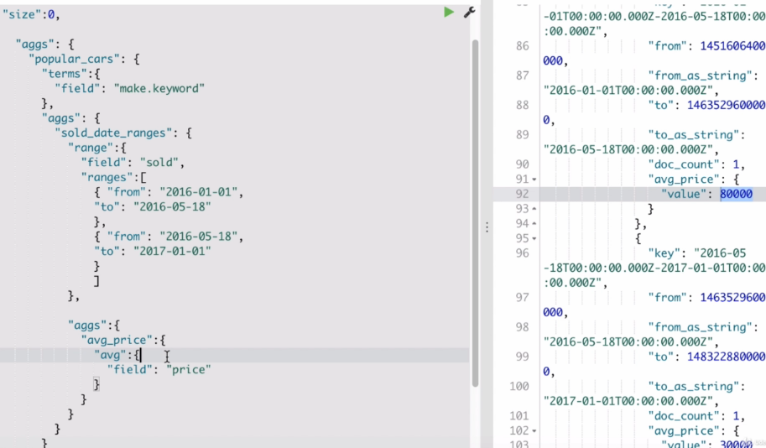

Example 2

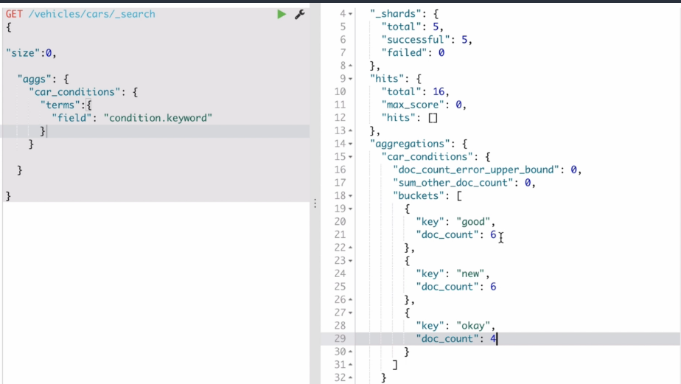

If we want to get the average price for different condition type of vehicle.

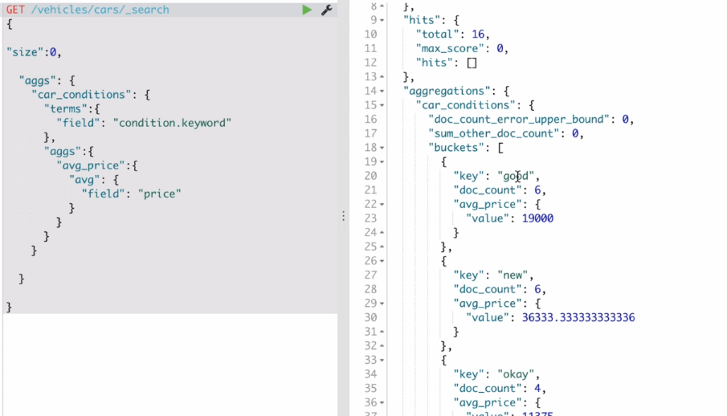

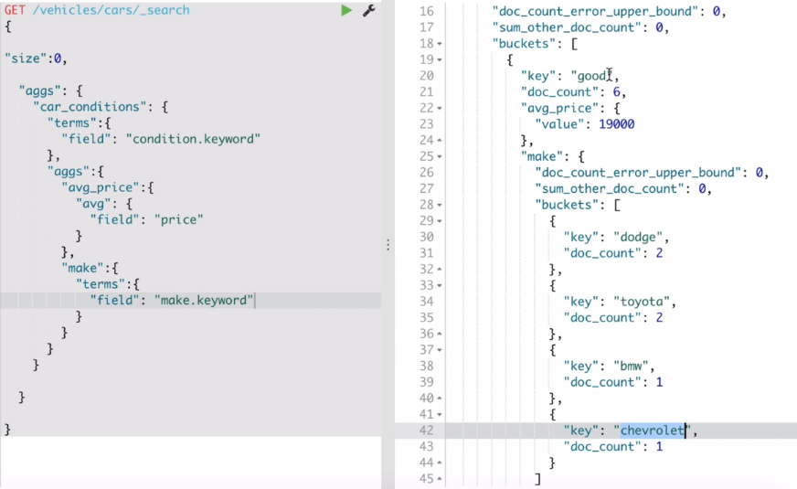

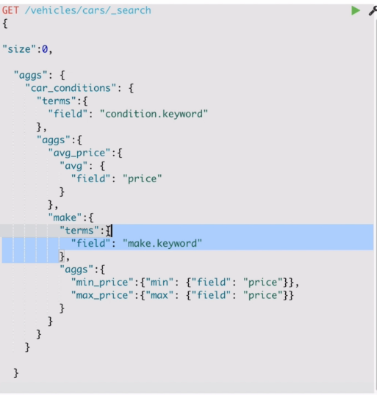

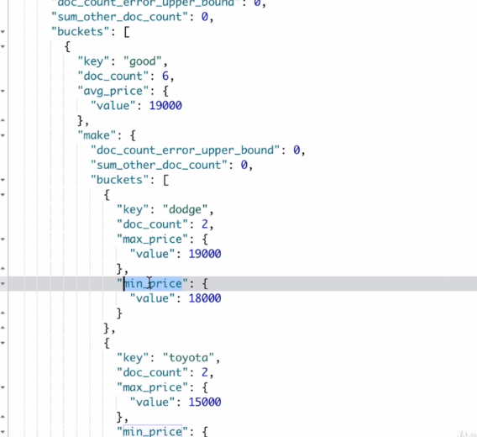

First the ES will the results based on queries and then based on this result scope aggregations will be performed. Then we can create buckets from these documents and can apply metrics on them. Also can create nested buckets inside a bucket.